Curriculum Area | AUTUMN |  | SPRING |  | SUMMER
RELIGION | Creation and the story of Abraham  Jesus teaches us to pray | Old Testament: Moses-King David  Advent | Christmas  Jesus Light of the World  Our Lady | Sharing in the life if Christ  Lent | Holy Week  Easter  Studying a different Faith: Judaism | Pentecost  Old Testament: Moses-King David  Feasts/Solemnities  Special roles and responsibilities
CATHOLIC SOCIAL TEACHING | Family and Community  Stewardship of God’s Creation | Dignity of the Human Person | Solidarity and the Common Good | Option for the Poor and Vulnerable | Dignity of Work and the Rights of Workers | Rights and Responsibilities
CATHOLIC SOCIAL TEACHING | Promotion of Peace
RELTIONSHIP EDUCATION | Get Up!  The Sacrament  We Don’t Have to be the Same (Part 2) | Respecting our Bodies  What is Puberty?  Changing Bodies | What Am I Looking At?  A Time for Everything | Jesus, My Friend  When Things Feel Bad?  Sharing Oline  Chatting Online | Safe In My Body  Drugs, Alcohol and Tobacco | A Community of Love  How do I Love Others?
PERSONAL, SOCIAL AND HEALTH EDUCATION | Shared Responsibilities  Communities |  | Economic Wellbeing: Money |  | Economic Wellbeing: Aspirations, Work and Careers
ENGLISH  KEY TEXTS | 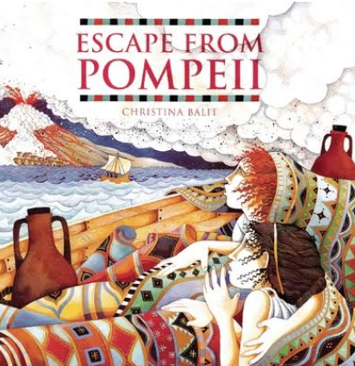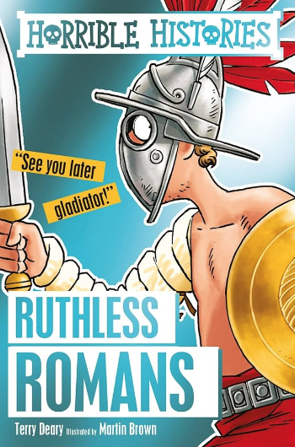  Poetry Unit: Poetry features - Boudicca |  | 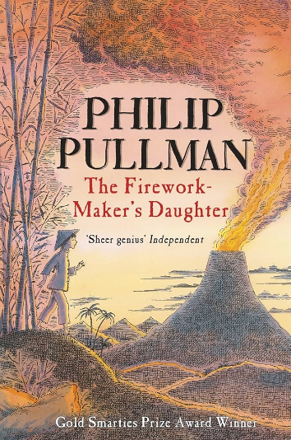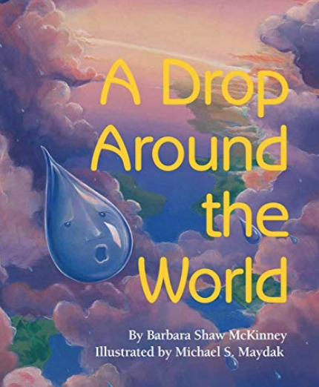  Poetry Unit: Exploring Poetic form |  | 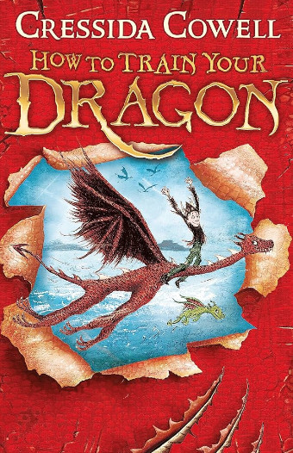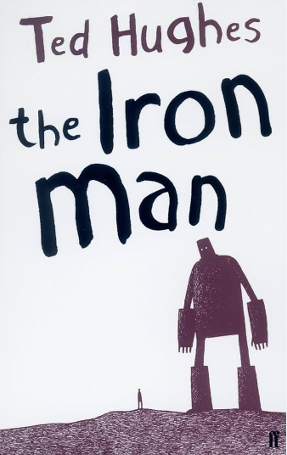  Poetry Unit: Exploring Poetic language
WRITING | Writing to Entertain  Writing to Inform  Writing to Persuade |  | Writing to Entertain  Writing to Inform  Writing to Persuade |  | Writing to Entertain  Writing to Inform  Writing to Persuade
MATHS | Place Value  Addition and Subtraction,  Measurement: Area,  Multiplication and division A |  | Multiplication and Division B,  Length and perimeter,  Fractions,  Decimals A |  | Decimals B,  Money, Time, Shape, Statistics,  Position and direction
SCIENCE | Sound | Electricity | States of Matter | All living things and their Habitats | Animals including humans  (digestion and teeth) | Animals including humans  (food chains)
GEOGRAPHY | Italy |  | Volcanoes and Earthquakes |  | North American Study
HISTORY | What changes did the Romans bring to Britain and what legacies did they leave? |  | What changes occurred in the Anglo-Saxon times? |  | Were the Vikings raiders or settlers/traders?
MUSIC | Musical Structures | Exploring Feelings When You Play | Compose with Your Friends | Feelings Through Music | Expression and Improvisation | The Show Must Go On
MUSIC | Musical Structures | Exploring Feelings When You Play | Djembe Drumming with Severn Arts |  | Expression and Improvisation | The Show Must Go On
ART& DESIGN | Collage & Mosaics  Patterns & forming images  Artist focus: Pietro Cavallini |  | Painting  Pointillism  Artist focus: George Seurat  Clifford Tjapaltjarri |  | Drawing – Self Portraits  (Shading & Tone)  Focus: Norse Art
DESIGN & TECHNOLOGY |  |  | Mechanisms  Alarm system |  | Mechanisms  Pop up books
PE 1 | Fitness | Dance | Swimming | Swimming | Athletics | Orienteering
PE 2 | Basketball | Tag Rugby | Football | Tennis | Dodgeball | Cricket
COMPUTING inc E-Safety | Purple Mash:  Coding  Online Safety  Spreadsheets |  | Purple Mash:  Writing for Different Audiences  Logo  Animation |  | Purple Mash:  Effective Searching  Hardware Investigators  Making Music
FRENCH | Se présenter: All about me  Where do you live?  Les numeros 12-20 |  | Saleur: Greetings  Langue en classe: Classroom language  Les numéros: 20-31  Les jours de la semaine: Days of the week  Mois et dates: Months and dates |  | Les couleurs: Colours  Parties du visage: Parts of the face  Parties du corps: Parts of the body
EDUCATIONAL VISITS | Bishop’s Wood – Roman Day |  |  |  | Singer’s Hill Synagogue

